Tatong Community Action Plan 2010 - 2014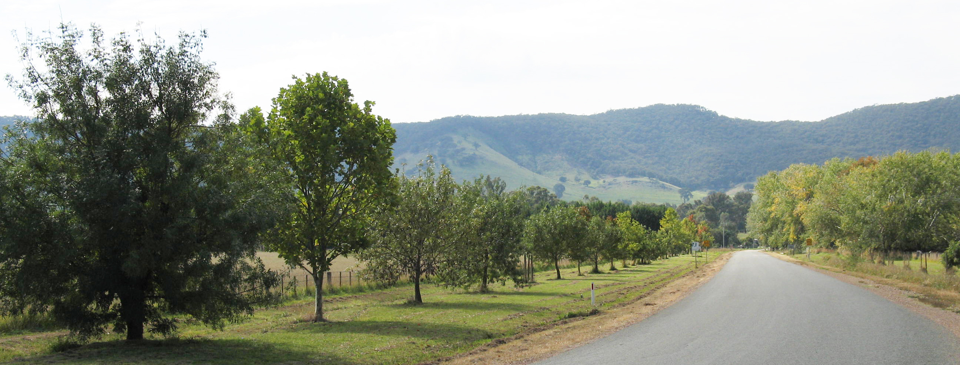
Prepared by the Tatong and District Lighthouse Steering Group
1/17/2010

Executive Summary: This document details a community led action plan that showcases a vision for the progressive development or re-development of the town of Tatong. Included in this plan is acknowledgement of Tatong as a progressive, cohesive, and forward thinking community, which values serenity, community cooperation, the beauty of the bush and all that Tatong offers for peaceful and harmonious co-existence with nature.

Contents
Introduction 4
Lighthouse Steering Group Vision 6
Community Vision 8
Community Stakeholders 8
How the Lighthouse Steering Group functions to support the community 9
Community Action Plan 2010 - 2014 9
Community Development Plan Priority 1 9
Community Development Plan Priority 2 10
Community Development Plan Priority 3 13
Council Support for the realisation of a Community Action Plan 2010-2014 16
Appendix A: Community Projects that value add to the town of Tatong 18

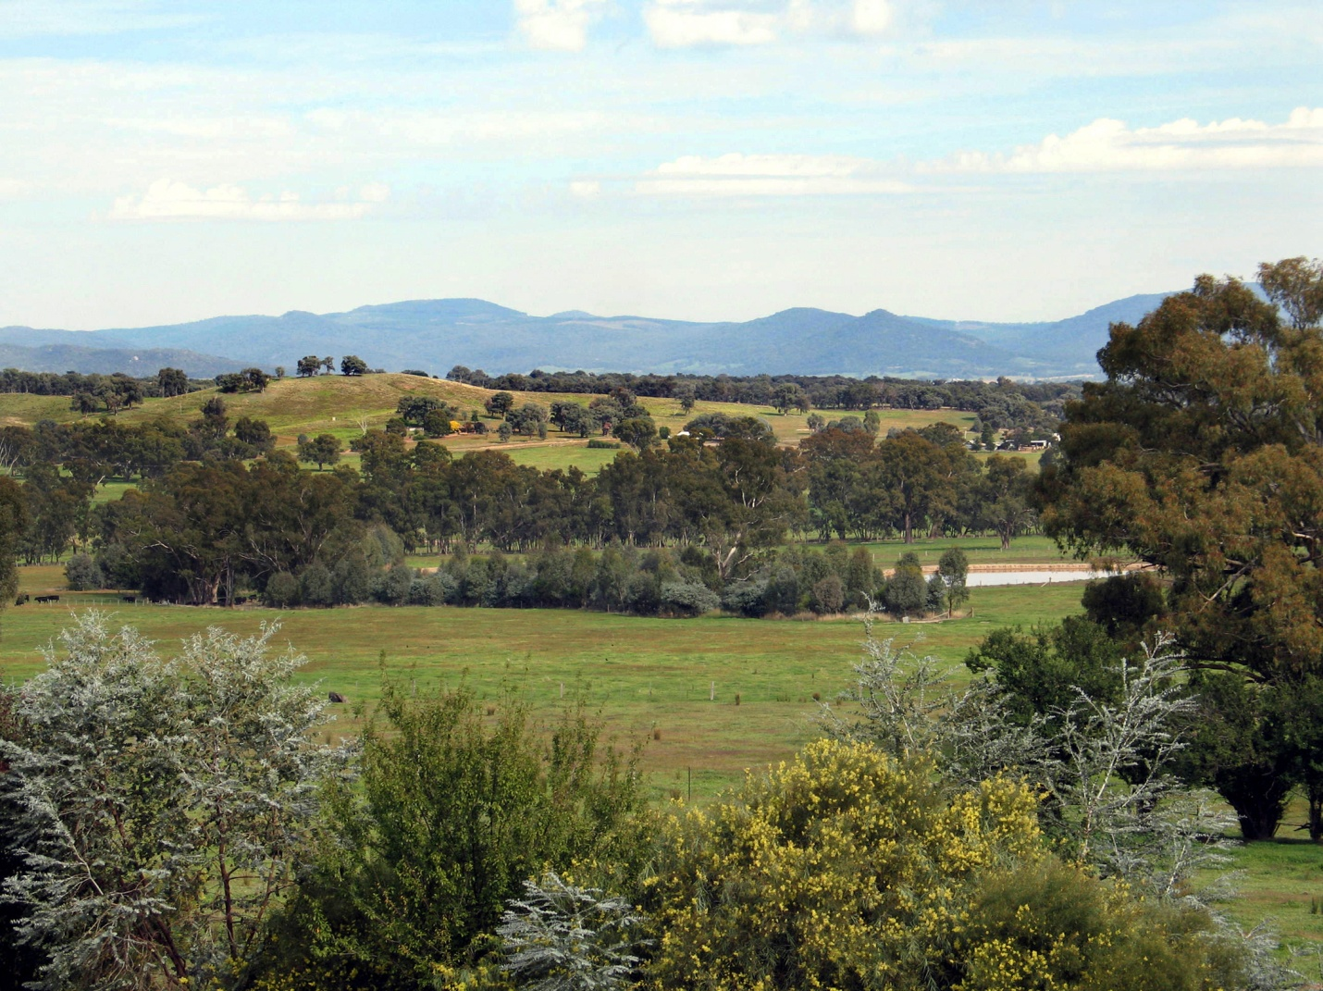

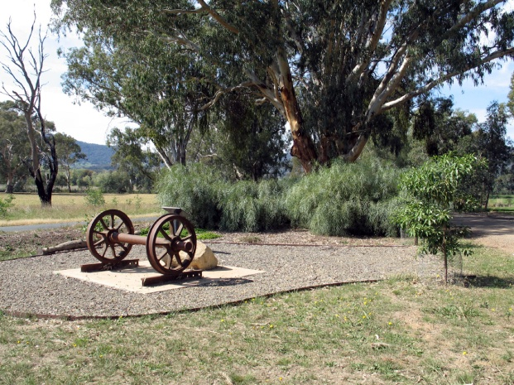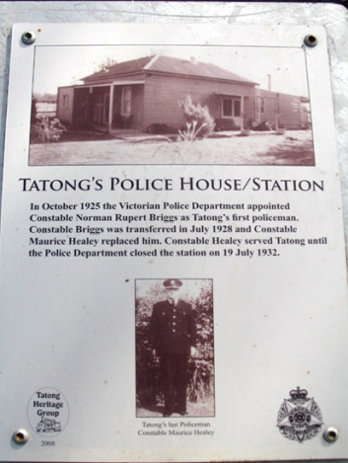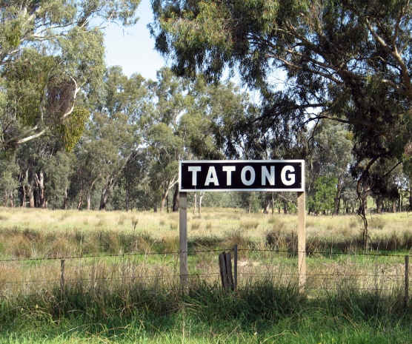

Introduction
The township of Tatong, which has a rich and diverse history, was established in the late 1800s (Dronseika, 2008) with the establishment of a general store; railway station and turntable; hotel; State School; and football and tennis grounds, among other things. The progressive development of the town is detailed in Those were the days at Tatong, a document produced by the Tatong Heritage Group that chronicles the early days of the town and its first inhabitants.
Suffice to say that since its inception the town of Tatong, while undergoing many changes over the last century, is characterised by a spirit of community pride and cohesiveness – which are some of the things that we love about living in Tatong. Today there are approximately 500 people who reside in the town of Tatong and the surrounding districts. The various interests of the town are currently served by 27 community groups, who work diligently to ensure that Tatong remains a viable, relevant, progressive, healthy and beautiful community in which to live. These important characteristics are hallmarks that set living in Tatong apart from other rural communities and signify Tatong as a healthy, restful, yet vibrant community. We value all that Tatong offers to its members. It is a peaceful place that our friends and family love to visit; it has varied and abundant bird and wildlife as well as scenic vistas and unique flora and fauna; we raise our children in a safe, clean and slow paced environment which is virtually crime and pollution free; and we enjoy a sense of spaciousness. Additionally, the community of Tatong is unique in that it is deeply committed to maintaining organised and ad hoc sporting and recreational events, such as the weekly exercise group, the archery and fishing clubs and of course our new affiliation with the Ovens and King Football Netball League is an achievement of which we are justifiably proud.
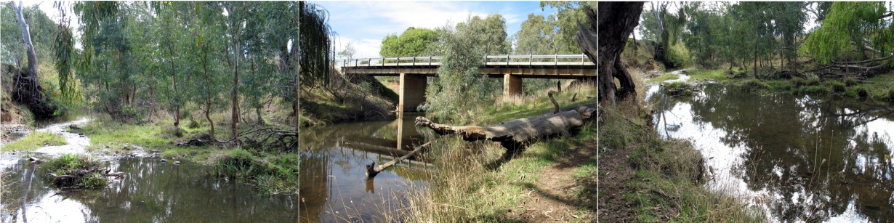
We enjoy gathering and socializing (as well as eating) at the renowned Tatong Tavern, where publicans past and future offer at no charge to the community a venue to hold community-based activities, such as the Royal Children’s Good Friday Appeal Auction, the monthly Tatong Market and the bi-monthy Neighborhood Watch meetings.

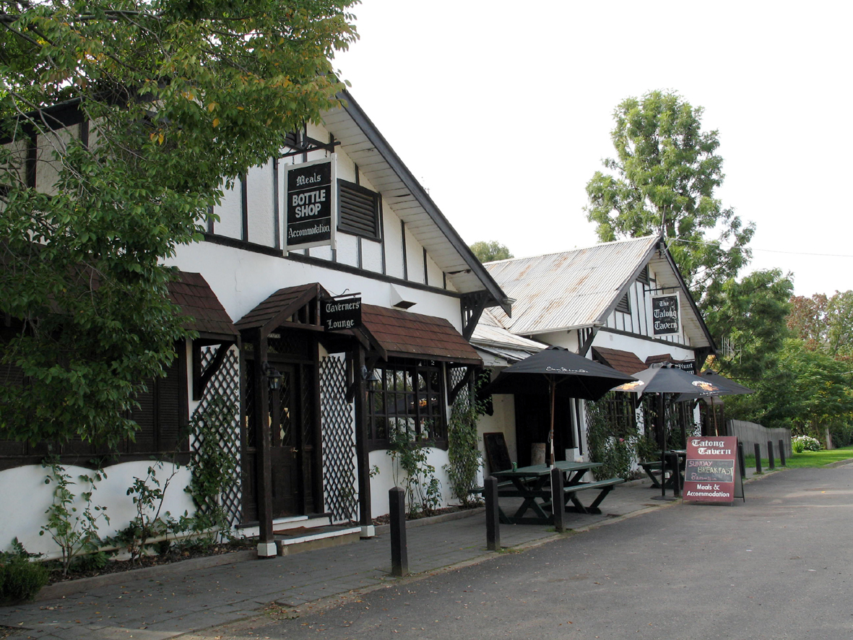

Tatong’s appeal is obvious to those who live there – it is in close proximity to the snow fields, wineries, the old tram line, as well as other places of historic interest such as the Kelly and Cork Trees. Importantly, we claim Tatong as a community where social cohesion is our reality and our civic pride is obvious.
The newly established Tatong and District Lighthouse Steering Group provide valuable oversight for community development initiatives. Members of the Steering Group network across and within groups to enhance intergroup communication, an important function that enables us to work cooperatively when mounting projects and submitting funding applications. As a Steering Group we are committed to undertaking a six monthly review of our activities and our achievements and activities are published monthly the Tatong Tattler. Additionally, Benalla Rural Council will be kept appraised of our accomplishments through submission of a yearly report.

Lighthouse Steering Group Vision
The Lighthouse Steering Group, established in 2009, considers that it is essential within communities to engender good-will, build partnerships between local groups and the residents of Tatong, and promote a spirit of co-operation. Working out of these principles ensures that initiatives have a greater likelihood of being supported, both in terms of how they are perceived in the eyes of the community and also, from a practical stance, of how responsive the community will be to calls for volunteers to support projects.
The goals of the Lighthouse Steering Groups are to:
- Develop a comprehensive understanding of the development needs of the community;
- Identify and implement strategies that are directed towards achieving community goals;
- Respond to new plans or ideas which are put forward by members of the community that have community support and serve the community’s interests;
- Develop a compendium of services and service providers that can offer their assistance to realise community goals;
- Liaise with Council on all matters in which Council has a legitimate role, to elicit their support and request their cooperation;
- Advocate for funding of community initiatives to Council and other government and non-government funding agencies;
- Assist the community with meeting its needs through actively seeking support for projects from community members; and
- Secure modern, well-equipped, safe community facilities that meet the diverse needs of the community and service their recreational, social and sporting needs.
To date we celebrate the following Lighthouse achievements:
- Development and detailed analysis of a community survey, which solicited community views regarding priorities for town development initiatives;
- Publication of 7 reports in the Tatong Tattler, to detail activities in which the Group has been involved and to share the findings from the community survey;
- Writing of 2 letters of support for the Tatong Memorial Hall Committee, to support their funding applications to upgrade facilities of Hall;
- Writing of a letter for the CFA ,to support their quest to establish a permanent water supply for the town of Tatong;
- Writing of a letter to Stephen Brown of the Department of Education and Early Childhood Development, to clarify the Education Department’s stand on the possible re-establishment of the Tatong School;
- Writing of a letter to the Tatong Heritage Group, to solicit their interest in becoming a lead body in the restoration of the School as a Community Learning Centre;
- Writing of a letter of support for the TFNC, to join with the Ovens and King Football Netball League;
- Creation of a Welcome Pack to be distributed to new residents of the town of Tatong;
- Establishment of an Email list, to keep members of the community up-to-date with Lighthouse initiatives;
- Construction of a Community Notice Board;
- Application to the Benalla Rural Council for approval to erect a What’s On in Tatong Notice Board;
- Meetings with various community stakeholder groups, to assist with the identification of their development needs;
- Development of the Community Action Plan 2010-2014;
- Winning of 2 community grants to the total of $25,000 for refurbishment of the Tatong Memorial Hall;
- Hosting of a Community Centre/Learning Exchange meeting in March to discuss the development of a Learning Exchange within the community of Tatong;
- Winning of various community grants to the amount of $22,084 for refurbishment of the Tatong Recreation Reserve; and
- Painting of community designed mural on the wall of the Tatong Recreation Reserve Sporting Club, which celebrates the merger of the Tatong Football Netball Club with the Ovens and King Football Netball League.
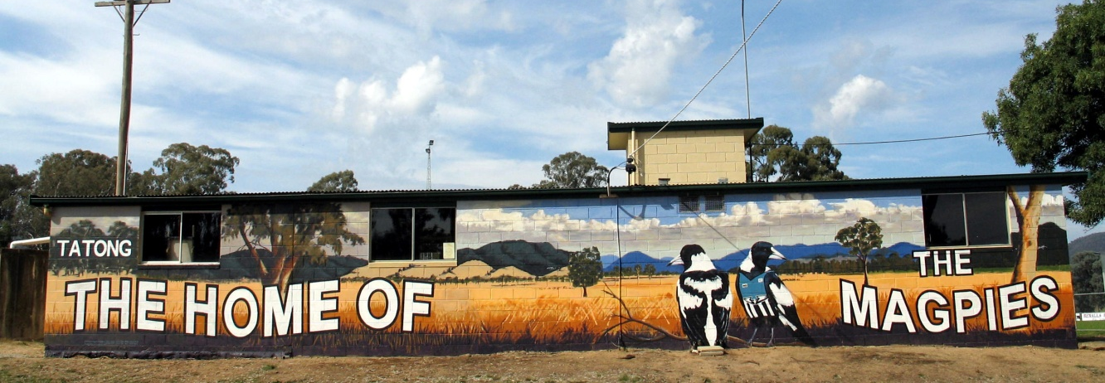

Community Vision
The vision for the town of Tatong pivots around 3 core yet intertwined objectives. The visions are:
- To maintain Tatong as a place of beauty that offers opportunities for peaceful and harmonious co-existence with nature;
- To foster a sense of community and civic pride through maintenance of Tatong as a welcoming and friendly community, which is progressive, growing and responsive to community needs; and
- To expand and redevelop community resources to keep pace with the recreational, diversion and safe living needs of the community.
Having an awareness of the vision of the community is crucial to the overall success of Lighthouse Steering Projects, as this knowledge potentially prevents the Lighthouse Steering Group from engaging in or supporting activities that are inappropriate in the eyes of the community. Further, the Lighthouse Steering Group exists to serve the needs and interests of the community and in this is driven by what the community has identified as its development needs.
In this action plan we highlight 3 community development initiatives that cannot be fully achieved within our limited resources and therefore require significant support from the Benalla Rural City Council and other funding bodies. Additionally, we celebrate and acknowledge Tatong as a resourceful community with a proud heritage of self-reliance. Therefore, in Appendix A we showcase a number of community initiatives that potentially will improve the community and ensure it does not stagnate. We will work over the next 4 year period to achieve the initiatives listed by a * and the remaining items will be lead items to inform the development of the Tatong Community Action Plan 2015-2019.

Community Stakeholders
Ultimately all those who reside in Tatong and the surrounding districts are the stakeholders to the Tatong Community Action Plan, as well as the various community groups and committees that service the needs of Tatong. These groups, together with a group contact person, are as follows:
The Recreation Reserve Joan Lewis
The Tatong Football Netball Club Anthony Hill
Tatong Tennis Club Madeleine deVries
CFA Alan Hawes
Tatong Magpies Sports Club Mark Saunders
Land Care Group Kevin Smith
Tatong Table Tennis RobErskine
The Tatong Anglers Max Jones
Tatong Good Friday Appeal Jade Kirk
Australia Day Committee Rick Hann
Tatong Heritage Group Bev Hakkennes
Tatong Tattler Andreas Stevenson
Tatong Young Bloods Emma Cavalot
Holland’s Creek Demonstration Reach Kevin Smith
Tatong Archery Group Mike Larkin
Tatong Artists Group Mike Larkin
Save the Tatong School Rick Hann
Tatong Village Market Larissa Montgomery
Tatong Memorial Hall Pat Manser
Red Cross collection Sue and Terry O’Brien
The Girls Shed Pat Manser
Walking Track Pat Manser
Neighbourhood Watch Brian Vial
Tatong Hornets 8-ball Tatong Tavern
Tatong and District Lighthouse Steering Group deSales Turner
Mothers Group Katie Lewis
Christmas Concert Tatong Young Bloods

How the Lighthouse Steering Group functions to support the community
Community harmony is important to the people who live in the town of Tatong and is a guiding principle upon which the Steering Group functions. Hence, the Lighthouse Steering Group primarily functions as a support group (as distinctly different from an initiating group) to existing community groups; and individuals and committees that wish to initiate projects or need help or support for projects particularly if they fall into priority areas 1-3 of the Community Action Plan.
Additionally, projects brought to the attention of the Steering Group that are outside of community priorities 1-3 are supported by the Group, provided that the project has merit and that the proposer, in the first instance, demonstrates that they have actively sought and obtained community support for the idea. See Appendix A for a list of projects identified by community members as ‘value adding’ to Tatong.

Community Action Plan 2010 - 2014
Having entered into consultation with primary stakeholders, the Lighthouse Steering Group identified priority development needs of this community and ways that the Steering Group can support such developments. From the outset it is transparently stated that the Steering Group is concerned that their support enables priority development plans and objectives to be realised. Constraints to success, both in the short and long term, are related to their lack of control over decisions made by funding bodies to enable community aspirations to be realised; practicalities associated with obtaining development and planning permits; and the general realisation that we are a small community with limited assets yet big ambitions to create a more vibrant and inclusive community. Nevertheless, our Community Action Plan acknowledges that if we do not articulate a development plan, our ability to realise our dreams will be severely hampered.

Community Development Plan Priority 1
As identified by the community, the Establishment of a permanent supply of water for the township, to be used in emergency situations as well as to support community members whose livelihood is affected by water shortages is paramount. To achieve this goal the Steering Group works in partnership with the Tatong Rural Fire Brigade, writing letters of support for funding submissions and offering its services to assist with refinement of infrastructure development plans. The Tatong RFB has accepted carriage for the realisation of Priority 1 – Establishment of a permanent water supply for the township and an evaluation meeting is scheduled for Jan 2011, to identify the extent to which this Priority has been achieved. Adjustments and refinements to the plan, if required, will be made accordingly.
We acknowledge that a confluence of events, including but not limited to the findings from the Royal Commission, have significant bearing on how this outcome is realised, and we stand in readiness to continue our support. To date a number of improvements to secure a permanent supply of water for Tatong have been realised and these include the placement of a bore and installation of 2 x 45,000 Litre water tanks at the Tatong RFB site. The bore to a depth of 96 meters produces 75L/m with a second pump that fills a stand pipe for delivery of community water when a drought is declared. The water from the bore contains 250ppm NaCl, which is an acceptable level for human consumption. The initiative was financed by Goulburn Murray Water and managed by the Benalla Council.
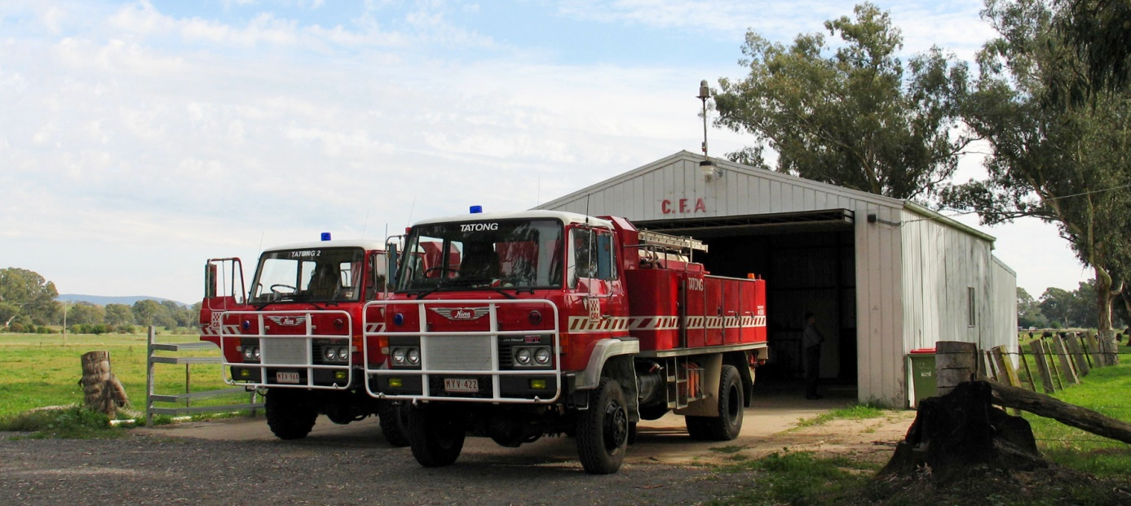

Community Development Plan Priority 2
Refurbishment and upgrade of existing community facilities is of particular importance to the people of Tatong. Hence, through consultation with key stakeholders we identified that the re-development of the Tatong Recreation Reserve is of high priority, as is the refurbishment and re-development of the Tatong Memorial Hall. The Recreation Reserve Committee, in consultation with an appointed consultant has accepted carriage for the realisation of Priority 2 – Redevelopment of the Tatong Recreation Research and will conduct a yearly evaluation meeting held in December to determine the extent to which progress has been made. At this time adjustments and refinements to the plan will be made and outcomes will be published in the Tatong Tattler.
The Tatong Memorial Hall Committee of Management has accepted carriage for the realisation of Priority 2 - Redevelopment of the Tatong Memorial Hall and will conduct yearly evaluation meetings held in January to determine the extent to which progress has been made. At this time adjustments and refinements to the plan will be made and outcomes will be published in the Tatong Tattler.
It is well known that vibrant communities often revolve around having sustainable recreational, social and sporting events (Community Facility Funding Program 2010/2011). Hence, our vision encompasses a goal to improve our sporting facilities; as well as provide more suitable and multi-use modern venues for general community based activities that meet the exercise, recreation and socialisation needs of members of this community.
To enable us to realise our goals we submit the following priority goals and indicative figures:

Tatong Recreation Reserve Plan for Re-Development, in Priority Order
- Extension of facility to create toilet and shower facilities for the newly developed Tatong Football and Netball Clubs. $150K.
- Creation of a watering system for irrigation of the grounds. $ 50K
- Resurfacing of the Tennis/ Netball courts. $ 90K
- Creation of a covered Play Ground area for children. $ 50K
- Levelling of the Fire Pit Area. $ 5K
(NB: We have secured finance for this improvement.)
- Creation of a shade area for spectators to sporting events. $ 10K
- Refurbishment of the kitchen and serving area of the clubroom. $ 20K
- Installation of a satellite dish at the Rec Reserve $ 10K
- Purchase of a community ride on mower $ 25K

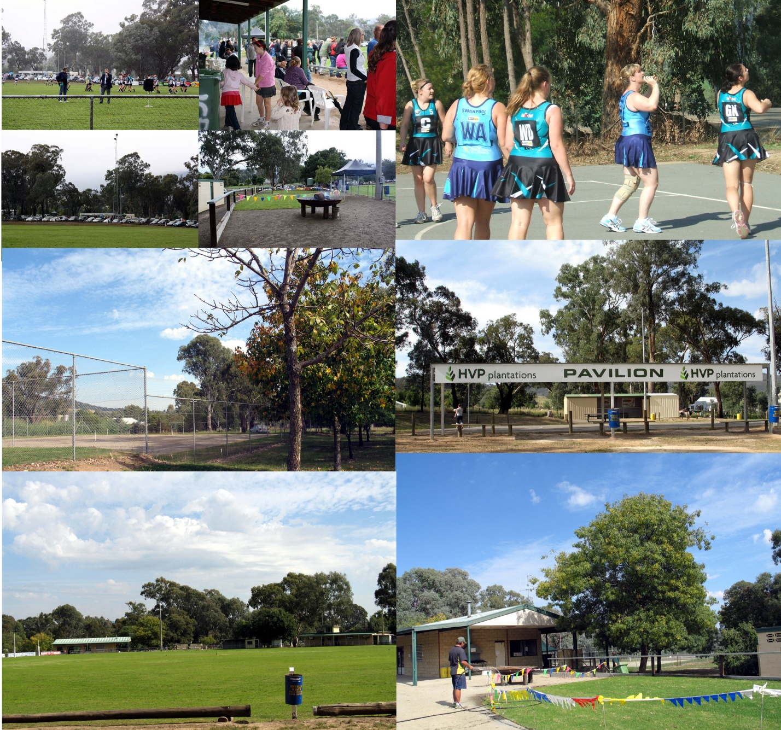

Tatong Memorial Hall Plan for Re-Development, in Priority Order
- Installation of a split system air conditioning unit. $16.6K
- Electrical upgrade $ 2.4K
- Resurfacing of floors. $ 6.8K
- Making of window coverings. $ 2.5K
- Remodelling of Kitchen Facilities. $50K
- Building an equipment storage facility and upgrade of entrance $10K
NB: A Community Development Grant was secured in February, 2010 for items 1-3 and work is currently underway

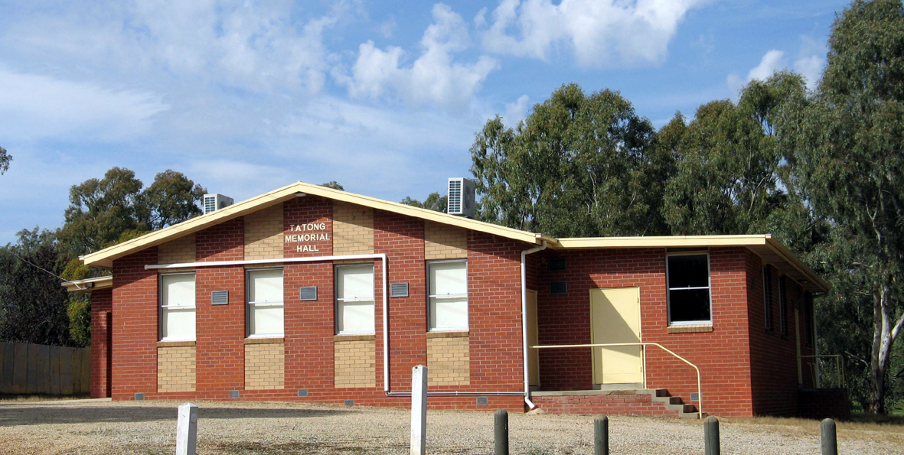

Community Development Plan Priority 3
Re-instatement of the Primary School in Tatong AND Development of a Community Centre at the site of the old Primary School has received strong community support.
The present School building has been un-occupied over the last 5 year period, it is deteriorating and some vandalism has occurred. Further, we have been advised that there is a termite problem and soft and hard furnishings were either removed when the School was decommissioned or are in sub-standard condition. Therefore, it is urgent that action be taken now to preserve this facility, the grounds, and all equipment presently located at the site, to keep them from deteriorating beyond a point of usefulness. This is particularly important if this building and its associated history is to be preserved for future generations. Members of the community as well as the parents of Tatong have not accepted that it is not possible for the School to be re-instated and they have assumed carriage for the realisation of Priority 3 – Re-instatement of a Primary School in Tatong. To this end a letter requesting an urgent review of the decision to decommission the School has been sent to Brian Collins, Education Regional Director, Hume. A decision on this matter is pending. If a window of opportunity is opened to re-instate the Primary School the parent group will form a Committee and work in close cooperation with the Education Department and the Benalla Rural City Council to develop an action plan for realisation of this vision.
Regardless of whether our goal to re-instate the School is realised, our secondary objective is to utilise the existing facility for development of a Community Centre. Of necessity, if the School is reinstated Community Centre activities would only be scheduled during out of school hours and school breaks. However, if the School is not reinstated the Community Centre would, over time, become fully operational.
We propose that multi-purpose use of the current facility is strategic, as multi-use buildings are becoming the rule, not the exception. Indeed, some suggest that multi-use of public facilities makes good economic sense, as under-utilised public facilities are inefficient and drain the public purse. To realise Priority 3 – Development of a Community Centre at the site of the old Primary School a Learning Exchange Committee has been formed to assume carriage for this objective and bi-yearly evaluation meetings held in July and January will be conducted to determine the extent to which progress has been made. At this time adjustments and refinements to the plan will be made and outcomes will be published in the Tatong Tattler.

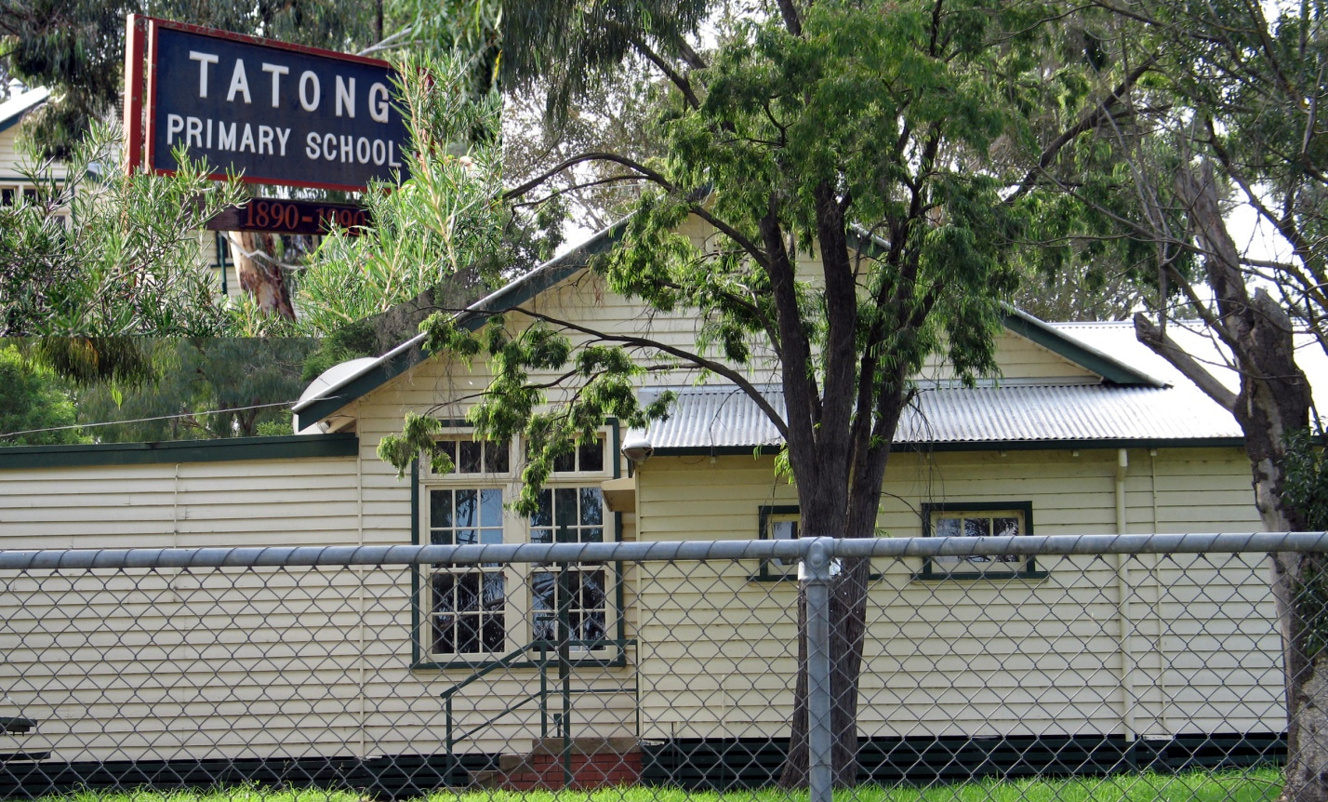

Tatong Re-instatement of the Primary School and Development of a Community Centre in Priority Order
- Petition Brian Collins, Education Director Hume Region for an official position on re-instating the Tatong Primary School;
- Develop an action plan in close cooperation with the Education Department and the Benalla Rural City Council should a window of opportunity be opened;
- Obtain expressions of interest from key community stakeholders, that articulates their vision and support for on-going and permanent use of the building and surrounding land;
- Establish a schedule of non-certificated learning and other activities to be held in a
newly established Community Centre, using the development model of the King Valley Learning Exchange. Learning Exchange Activities to be mounted as appropriate in the existing facility when not in use as a Primary School;
- Petition the DSE, who are the custodians of Crown Land, requesting their strong commitment to work with Council to retain the site for use in the first instance as a Primary School and secondarily for Community Centre activities;
- Petition the Minister of Education for possible formal closure of the School pending the outcome of objective 1;
- Scope the development and refurbishment needs of the building, to enable it to used by the Community for community purposes;
- Identify the equipment needs for activities deemed appropriate for the building and surrounding land;
- Employ an architect to draw up plans to enable safe and efficient utilisation of the building and land;
- Petition for funding to enable designation of the site for community use purposes;
- Ensure that the structure and land is brought up to code and meets safety requirements; and
- Investigate the feasibility of re-locating the School to the Recreation Reserve or other donated land within the community of Tatong should this become necessary.

Council Support for the realisation of a Community Action Plan 2010-2014

By extending an invitation to the town of Tatong to be engaged in Lighthouse Projects, Council offered its support to the creation and implementation of community-led development initiatives. The Benalla Rural City Council understands that supporting communities who demonstrate a capacity to be self-determined is a step in the right direction, as it fosters healthy communities that work cooperatively and harmoniously to achieve their visions and goals. Our Community Action Plan resonates with the Council Plan 2009-2013, specifically with Strategic Objectives 3.1; 3.6 and 3.11.
The visions outlined within this Community Action Plan attest to the capacity of the people of Tatong to engage in community planning and to do so in a spirit of cooperation. Amidst the strong ethos of community volunteering that is evident in the township of Tatong; we acknowledge that our visions will have a greater chance of coming to fruition through creation of a strong partnership with Council. Thus, we offer our insights into what this community needs to sustain momentum; create a climate of excitement about the future of Tatong; and thereby improve the overall physical, emotional, and social wellbeing of members of this community. We are excited by the prospect of actively working with Council to achieve our goals and look forward, with anticipation, to seeing our initiatives prioritised and partially funded by the Benalla Council.
Over the years we have faced a number of challenges related to meeting our growth and development needs and we have achieved many successes. As previously mentioned, within the town there are 27 committees or groups that serve the needs of the town that testify to a claim that Tatong is a thriving and vibrant community. All members of this community were provided with an opportunity to be actively involved in the creation of Lighthouse Projects. Whilst it is true that not all members of the community responded to the multiple calls to be involved, the initiatives outlined in this plan can be viewed as a basis of all discussions, actions and developments that occur over the next 4 year period that lead to community implementation in partnership with Council or other government and non-government agencies.
Much of what the community has accomplished has been without receiving outside support, and while our self-determination is to be commended, we believe it is timely for us to engage in community planning that fits under the umbrella of Council’s support and assistance. It is with pride that we present to the community of Tatong and the Benalla Council this Community Action Plan 2010-2014 and we look forward to achieving our visions over the next 4 year period.
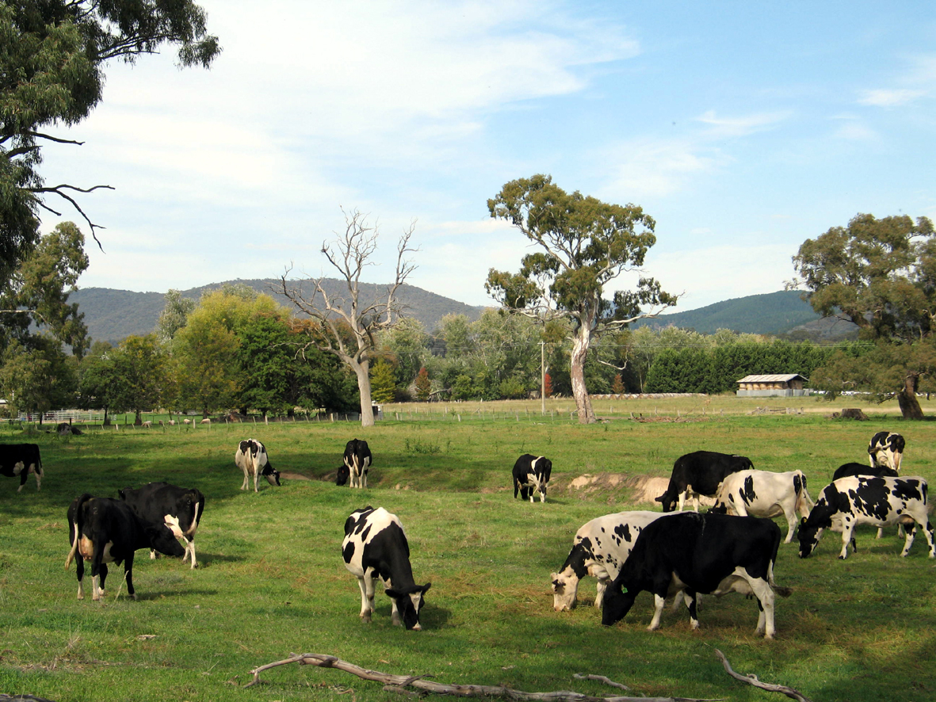

Appendix A: Community Projects that value add to the town of Tatong

Project Carriage
*Create walking and bicycle paths Tatong Walkers Inc
Build a dam in the catchment area and release enough water to keep Tatong Heritage Group
Holland’s flowing through the summer months and to keep native fish
and crustaceans alive;
*Secure better road maintenance; Neighbourhood Watch
*Beautify the town centre; Tatong Tavern
Create a weir for a swimming hole near bridge and to CFA Tatong
help with permanent water supply for community and CFA;
Erect a playground at Tatong Bridge reserve; Kelly Cairncross
Purchase block adjacent to Memorial Hall to develop Mike Larkin
wet lands area;
Create a covered BBQ and landscaping at Tatong Bridge area; Mark Osborne
Upgrade the picnic area near bridge; Larissa Montgomery
*Erect a Soldiers’ memorial and flagpole in Tatong; Patricia Manser
*Develop a Welcome to Tatong pack; Carol Lewis
*Erect a ‘What’s on in Tatong’ notice board; Larissa Scott
*Create a community notice board Michael Turner
*Establish a learning exchange for the town of Tatong Maeve Larkin
NB: An * against projects indicates a plan that has or is being achieved through leadership of members of the community of Tatong

